Part one: Worms of interest and Mollusca

We have received some specimens that we had hoped would come last week. Oh well! Better late than never.

Please work with these organisms carefully and respectfully. These are two clades Sipuncula and Nemertea that most students will never get the opportunity to observe.

1. **Sipuncula**

Obtain a beaker (250 ml.) and fill it with 2 inches of sand and then seawater (from main tank). Hopefully you will be able to focus on the interface of sand and seawater. You need enough sand for the larger peanut worms they sent to burrow in. One of the small round dishes may work but make sure you can put enough water after the sand is placed in it for the worm to feed comfortably. Set aside until the sand settles.

Add a peanut worm to your container and watch it settle in. Please use gloves when transferring worms so as not to contaminate their water. Carefully coax a worm into a small dish, trying to keep it in water and place it in water in your dish or beaker. It may take a few minutes before it is comfortable enough to burrow. **Describe how it moves and burrows.**

**Add some crushed fish food (just a pinch) to the container and videotape feeding in Sipunculids.** Not all specimens may feed, so be patient and allow other students to observe your preps if your specimen proves less intimidated by new surroundings than most. The introvert you will observe being used is very long and often can be extended 2-3 X times the length of the worm. **Describe how your worm feeds in your journal.**

**2. Nemertea**

We have *Lineus sp.* , a very small nemertean that is found off our coast. No worm beats the Nemertean for surprising changes in length. Place a specimen in a small dish of seawater and place the container under the stereomicroscope. Again try not to handle the specimens, use gloves and use small little round dishes to trap and transfer animals into larger containers.

Watch the animal move. You may want to prove a small rock or shell that the specimen can hide under if it doesn’t settle down. Place the rock or shell at one end of the dish or simply wait for the specimen to choose a spot to settle down. Add a black worm, flake of fish food, bit of egg or very small piece of shrimp at the other end. **Videotape the feeding behavior of the nemertean.**

**Mollusca**

The phylum Mollusca is one of the largest of the invertebrate clades, both in the size of certain species and the number of species which have been described. Early mollusks were abundant in Cambrian seas and the long history of the group is reflected today in the variation among Molluscan types. This variation also attests to the success and plasticity of the basic Molluscan body plan.

Background

The basic molluscan body plan is bilaterally symmetrical, unsegmented, and coelomate and the body is divided into a ventral muscular foot, a dorsal visceral mass, and a **mantle** of epithelium and other tissue which encloses the dorsal surface of the body. The cavity between the mantle and visceral mass is termed the **mantle cavity**. The visceral mass is provided with a blood circulatory system generally containing the oxygen carrying copper pigment haemocyanin, a variably specialized and cephalized nervous system with ganglia and ventral nerve cords, a well-developed excretory system, and a distinct reproductive system. The mantle cavity generally houses an efficient respiratory system. As will be seen in today's and next week’s laboratory, however, among the molluscan clades (classes) almost every one of the organ systems mentioned above shows a wide spectrum of variation.

Mollusks apparently arose as creeping types, probably living on hard surfaces and scraping their food from the substrate by means of a unique organ, the **radula**, which is found in all modern clades except the Bivalvia (Pelecypoda). Bivalves have extensively modified their gills (**ctenidia**) for filtering particulate food from the water column. The molluscs are closely related to the annelids. This affinity is seen in the similar developmental patterns within the two groups, the **trochophore larva**, and the possible vestiges of segmentation seen in some of the primitive molluscs.

**We will use three basic model organisms. Gastropods are readily available. We can easily work with them and see basic variation within this large clade in relation to lifestyle. The squid because frozen specimens are large and so easily dissected will serve as our model for Cephalopods. Everyone should also dissect one of the bivalves available and compare their anatomy to that of the squid and snail (via diagrams as dissecting a gastropod can be a very time consuming experience, requiring a lot of patience). Dissections will be done next week.**

### **CLASS GASTROPODA: The snail**

The gastropods are more similar to the ancestral molluscan form than any of the other molluscan classes we will be examining today. They differ from the primitive ancestor in having an enlarged head and visceral mass, in most cases a logarithmically spiraled shell, and a visceral mass that has undergone a 180° rotation during development (**torsion**), so that the gills and anus are located on the anterior end of the snail.

3. Look for the dish that has a large number of snails in it**. Every group takes ten and determines how many turn to the right or left. Be sure you tally class frequencies before leaving. Discuss in your notebook, the basis for this phenomenon.**

4. Each group will do two different species of snails.

Locomotion:

Locomotion in most gastropods is accomplished by muscular contractions of the foot aided by mucus secretion. Exceptions to this general pattern include swimming gastropods and gastropods that use cilia to locomote. In gastropods that move by the muscle/mucus method, there are two specific ways by which movement is achieved: 1) **direct muscular waves** where the posterior edge of the foot is lifted, moved forward and then this advancing wave is propagated forward and 2) **retrograde muscular waves** where the anterior end of the foot is stretched and attached and the advancing wave is propagated backwards.

a**. Watch your snails crawl across a glass surface. Observe and describe the motion of the foot. Time the snail as it moves along the surface. Calculate average speed. Calculate feet per minute and miles per hour.**

Some convenient conversions:

cm/min x 1.97 = feet/hour; ft/min x 0.0114 = mi/hr;

cm/min x 0.6 = meters/hr.

**b. Feeding: action of the radula.**

**Slides have been coated with food at one end. We should also have chunks of semi-clear gelatin. Allow the snails to start feeding on the slide and then flip it over gently so you can observe the radula. Describe feeding by each species and try to get a photograph or video of the radula if you can. Examine the marks let in the dried food by the scraping radula. Count the strokes of the radula per minute if possible**.

c. Variation among species. Describe the shell of each species. One complete circle of the shell is a **whorl** and the edges of each whorl are connected to the next by **suture lines**. These lines are often sculptured and can form spines. Like all mollusk shells, growth lines are visible on the surface of the shell and the oldest part of the shell is the **apex**.

# Measure its size and the size of its footprint. What is the size of the operculum an extra shell on the dorsal surface of the foot (your species may not have one), relative to the size of the foot? How long are the tentacles and are there other structures present that could serve as indicators of ecology or life style. For example, burrowers have a siphon that remains above the ground, allowing oxygen exchange. Others may use siphons and other extensions in various unexpected ways to obtain food.

# 5. *Melongena corona.* Place some food in a small test tube some distance away from these snails. Fish food will suffice. Then observe feeding.

[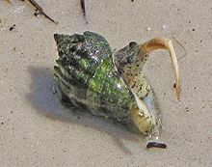](http://en.wikipedia.org/wiki/File:Melongena_corona_4.jpg)

Regroup and discuss the variation in snail morphology observed by the class as a whole.

**6. Observe the lettuce nudibranchs in the main tank**. Torsion in nudibranchs has been reversed. **What does this mean?** Your instructor may dislodge one of the nudibranchs so you can observe how well it floats in the water column until it finds a place to settle. Nudibranchs are great shape shifters.  **How could this prove an advantage to this species, which really has no other defense than camouflage?**

**7. Polyplacophora or chitins**

Their body form is specially adapted for the rough conditions associated with the intertidal zone of the oceans. When chitons are active they slowly creep across the rocks feeding on encrusted algae and other organic debris. If threatened they can roll up into a ball surrounded by the protective armor of their shell.

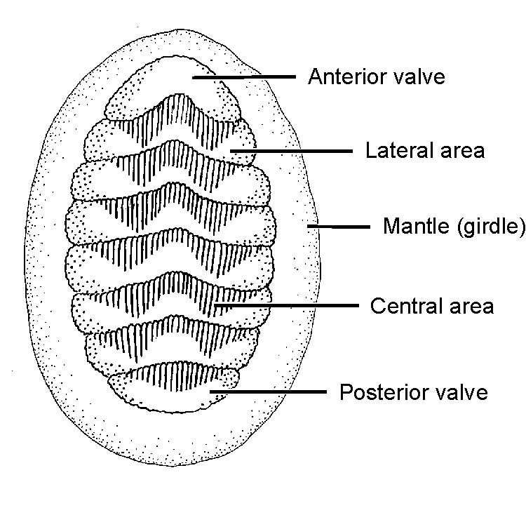

Obtain a chiton. Count the number of dorsal valves. Around the edge of the chiton is a muscular **girdle** with lateral edges of the eight valves embedded in it. The girdle is an exposed part of the **mantle**, the rest is underneath the plates and, depending on the specimen, you will be able to see the needle-like **calcareous spicules** embedded there. The most primitive molluscs didn’t have a shell and were protected by spicules much like those around the edge of the chiton.

Turn you animal over and observe the ventral surface.

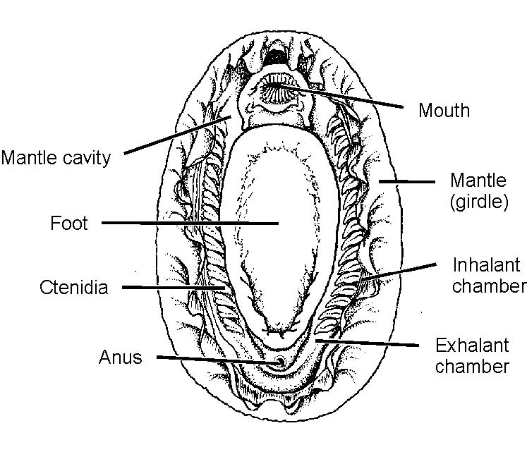

The large oval **foot** dominates the ventral surface of a chiton and along its lateral edges are the **mantle cavity** includes grooves formed from a trough between the foot on the inside and the fleshy girdle. Inside the mantle cavity you can see the multiple **ctenidia** used for gas exchange. The **mouth** is easy to see at the anterior end but there are neither eyes nor tentacles associated with it. At the opposite end, the **anus** is located on the roof of the mantle cavity, on the tip of a small papillae. C**ilia** on the surface of the ctendia propel water through the mantle cavity pulling it in at the anterior end surrounding the mouth, down the two mantle cavities on each side, and over the ctenidia. At the back the left and right mantle cavities fuse to form a single **exhalent canal** where the anal opening is located. If you look closely in the region of the last few ctenidia you may also be able to see **nephridiopores** or **gonopores** that open into this posterior part of the mantle cavity.

**Take a photograph of the ventral surface and label the ctenidia and mouth at least. Extra credit for anything else you can see.**

**8. Limpets**

**Limpets are gastropods that superficially resemble chitons and monoplacophorans.**

Limpets have a distinctive, oval shaped shell, with the peak more-or-less near the center, their strong muscular foot can grab small imperfections in the rock surface, and grasp very strongly. In all true limpets the mantle has developed a considerable overhang, so that there is a groove which runs around the inside of the shell called the **mantle groove**. It is through this groove that the water current flows.

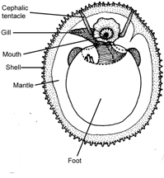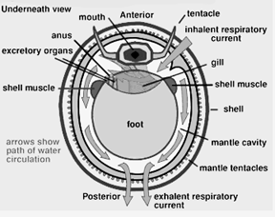

Limpets superficially resemble monoplacophora, the most primitive clade of mollusca.

Take a photograph of the dossal surface of your limpet, using the diagrams above to identify important structures. Then compare it to the diagram of a monoplacophoran provided. **Compare the “head” and placement of gills (ctenedia) in the two groups.** We will discuss the monoplacophora in lecture.

Monoplacophoran: ventral view--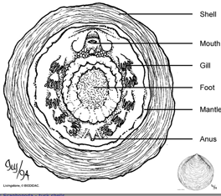

# 9. Bivalves or PELECYPODA

Bivalves do not initially appear to have much in common with snails or the primitive molluscan forms except for their protective shell. Bivalves are generally sedentary. The foot, visceral mass, and mantle cavity dominate the body, and the head is suppressed. Bivalves have developed from the primitive molluscan form by enlarging the mantle and dividing it into symmetrical halves hanging down on both sides of the body, enlarging the gills in the now huge mantle cavity, and extending the foot downward between the mantle folds as a blade‑like structure. Bivalves have lost the radula and the majority are ciliary feeders with large, platelike food‑gathering gills (**ctenidia**). The extensive mantle encloses the entire body in two symmetrical flaps, which secretes a hinged, two‑part shell.

We have mussels available.

Mussels are bivalves molluscs. The external shell is made of two hinged halves or **"valves".** The valves are joined together on the outside by a ligament, and can be closed by strong internal muscles. Mussel shells have a number of functions, including support for internal organs, protection from predators and protection against drying out. The **foot is tongue-like in shape**, it has a groove in it called the byssus pit. This pit secretes a sticky material which hardens on contact with seawater. This material forms strong, elastic threads that hold the mussel tightly to a surface

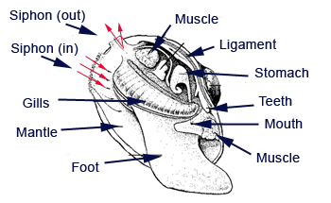

They are filter feeders, pumping water through a **siphon into gill filaments** which filter out small food particles like phytoplankton, zooplankton and other organic material. The waste water, conatining sediment, is pumped out through another siphon while the food is retained and passed into the stomach for digestion.

Place a small amount of sand in the bottom of a dish and some sea water.. Add a mussel. Again use gloves and make sure you do not expose the mussel to air. Examine the shell to see what other creatures if any are using the mussel as housing.

Once the animal settles and appears to either extend a foot or open its shell a bit, add some phyto-food, suspended phytoplanton to the dish and see if you can see water moving in and out of the mussel. Much of the sorting in mussels is done by the mouth palps and you may be able to see some movement of particles of zooplankton if feed along these palps. Try to video tape feeding if your specimen is cooperative.